MINI PROJECT - DATA ANLAYSIS USING EXCEL AND POWERBI

DOCUMENTATION

DAF69 – MARIA VANESSA

PHASE 1

DATA PRE-PROCESSING USING EXCEL
Zomato Restaurant Dataset

Raw data link: https://www.kaggle.com/datasets/srisyra02/zomato-market-analysis

|Original size: 9,551 rows × 21 columns

Objective
To clean and transform the raw Zomato restaurant dataset using Excel operations: duplicate removal, missing-value handling, format standardization, calculated fields, filtering/sorting, and PivotTable-style analysis.

Initial Data Quality Findings
• Records: 9,551
• Columns: 21
• Full-row duplicates: 0
• Duplicate Restaurant IDs: 0
• Missing cells: 9
• Missing Cuisines: 9

Remove duplicates
Use Data → Remove Duplicates and select all columns for a complete-row check. Also verify Restaurant ID uniqueness.
Result: No full-row duplicates and no duplicate Restaurant IDs were found, so nothing was deleted.
Before:
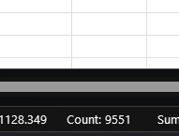
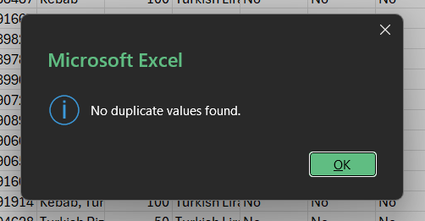

Handle missing values
Filter for blanks. Only Cuisines has missing values. Replace blanks with the explicit label “Not Specified” so records remain available for analysis.
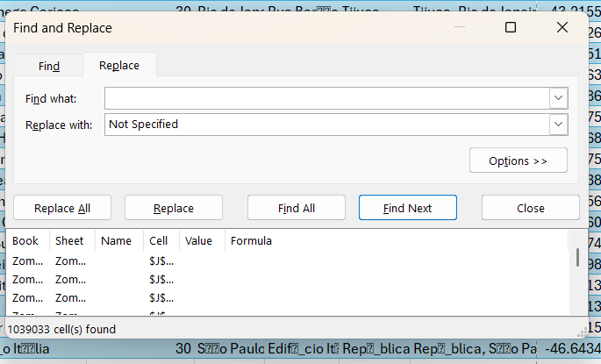

Standardize formats
Trim text fields; standardize Yes/No fields; keep numeric columns numeric; correct common, unambiguous encoding artifacts found in the supplied CSV.

Create calculated fields
Cost Category: 1 Budget, 2 Moderate, 3 Premium, 4 Luxury.
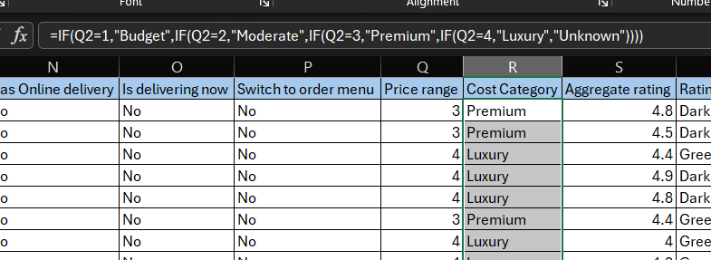
Rating Category: Not Rated/Poor/Average/Good/Very Good/Excellent based on rating bands.
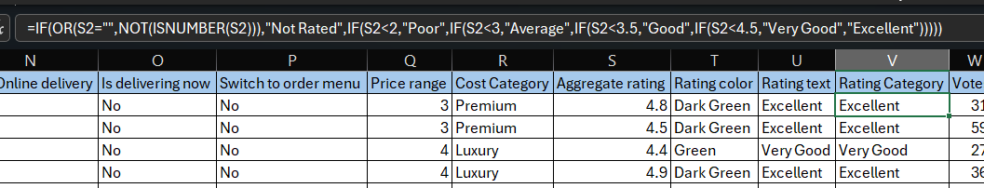
Online Delivery Flag: Yes=1, No=0.
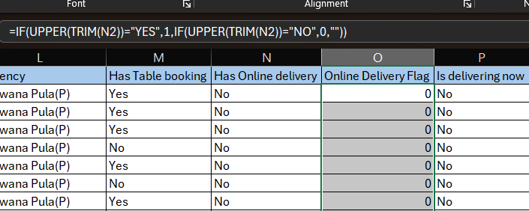

Filter and sort
Filter Aggregate rating to ≥4.5 and sort by Aggregate rating descending, then Votes descending.

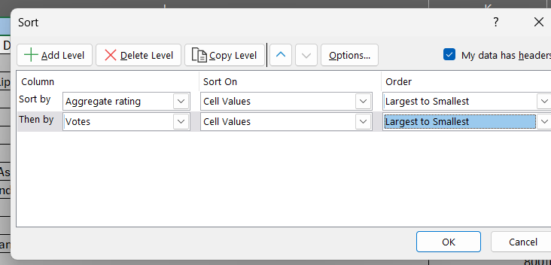
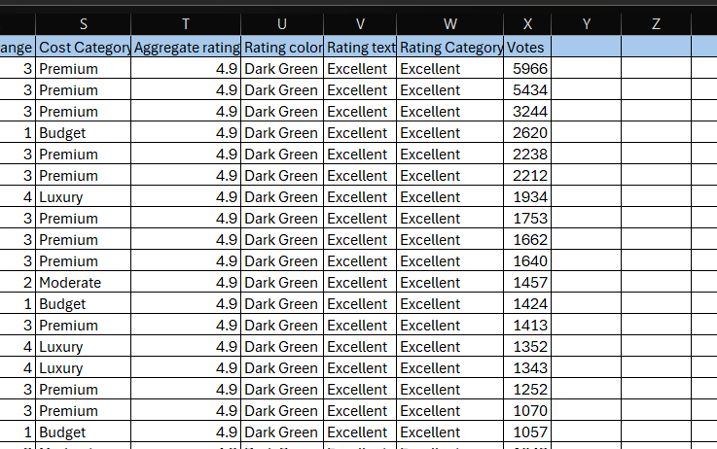

Create Pivot Tables
Create City and Rating Category summaries using rows and value aggregations.
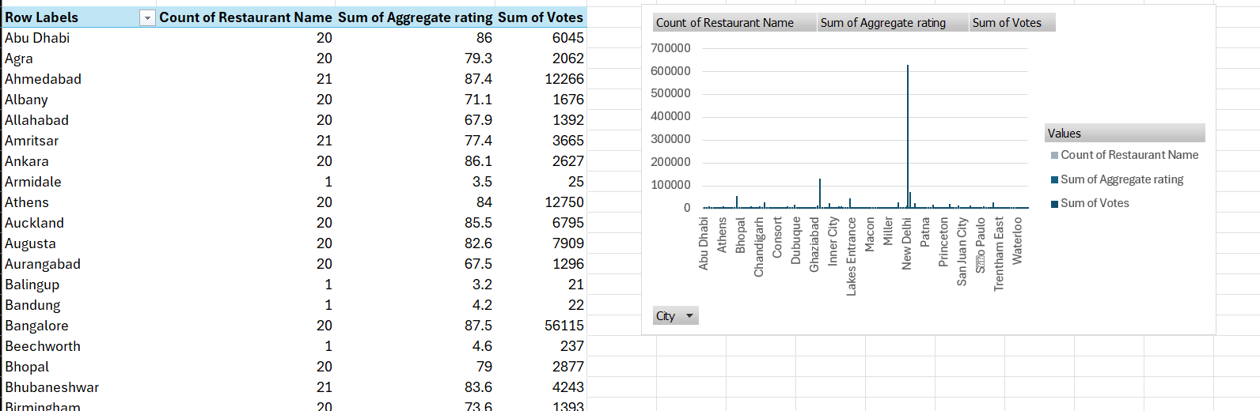

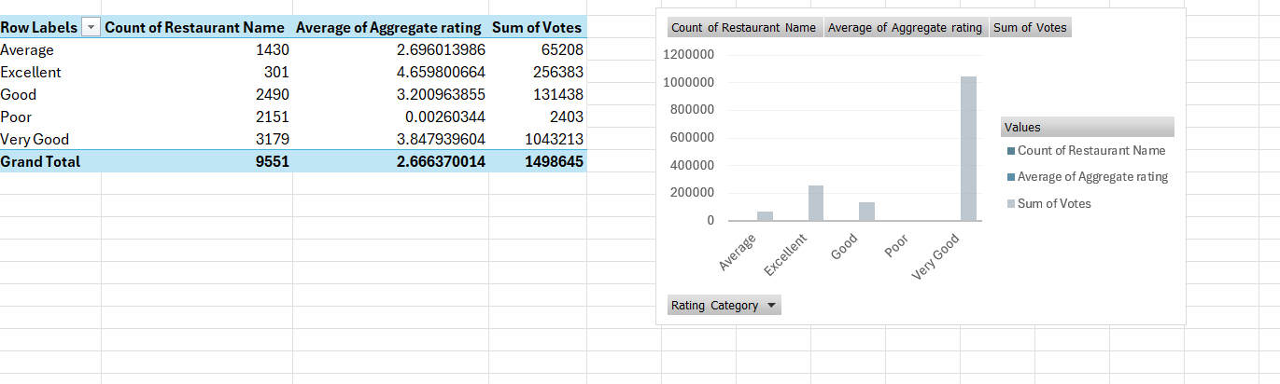

PHASE 2

Data Visualization using Power BI –
Zomato Restaurant Analysis

Objective
To develop an interactive Power BI dashboard using the cleaned Zomato restaurant dataset. The dashboard aims to communicate meaningful insights through appropriate visualizations, KPI cards, interactive slicers, filters and visual interactions.

Tools Used
- Microsoft Power BI Desktop
- Microsoft Excel
- Power Query Editor
- DAX (Data Analysis Expressions)

Implementation and Documentation

Step 1: Data Import and Transformation
The cleaned Zomato Excel dataset was imported into Power BI Desktop. Power Query Editor was used to verify column names, data types and data consistency. Numeric, decimal and text columns were assigned appropriate data types.
Result: The dataset was successfully loaded into Power BI for visualization.

Step 2: Creation of DAX Measures
DAX measures were created to calculate Total Restaurants, Average Rating, Total Votes, Online Delivery Restaurants and Online Delivery Percentage.
Result: Dynamic measures were created to support dashboard analysis.

Step 3: KPI Cards
Four KPI cards were created to display Total Restaurants, Average Rating, Total Votes and Online Delivery Percentage.
Result: Key business metrics became visible at a glance.

Step 4: City Analysis
A clustered bar chart was created to display restaurant counts by city. A Top 10 filter was applied to highlight the cities with the highest restaurant concentration.
Result: The visualization enables comparison of restaurant distribution across cities.

Step 5: Rating Category Analysis
A clustered column chart was created to display restaurant counts across Not Rated, Poor, Average, Good, Very Good and Excellent categories.
Result: The chart provides an overview of restaurant rating distribution.

Step 6: Online Delivery Analysis
A donut chart was created to compare restaurants offering online delivery with restaurants that do not provide this service.
Result: The proportion of online delivery availability can be easily understood.

Step 7: Cost Category Analysis
A clustered bar chart was created to compare restaurant counts across Budget, Moderate, Premium and Luxury categories.
Result: Restaurant distribution by pricing level is visually represented.

Step 8: Cost and Rating Relationship
A scatter chart was created using Average Cost for two and Aggregate rating to examine the relationship between restaurant pricing and ratings.
Result: The visualization helps explore whether higher restaurant costs correspond to higher ratings.

Step 9: Interactive Slicers
Slicers were added for City, Rating Category and Cost Category.
Result: Users can dynamically filter the dashboard according to their selected criteria.

Step 10: Visual Interactions and Formatting
Visual interactions were configured using Edit Interactions. Titles, axis labels, legends, data labels and consistent formatting were applied to improve readability.
Result: The dashboard became interactive, visually organized and easier to understand.

Final Outcome
An interactive Zomato Restaurant Analysis Dashboard was developed in Power BI. It includes multiple visualizations, KPI cards, slicers and dynamic filtering capabilities to support restaurant distribution, customer rating, pricing and online delivery analysis.

